1. Frontend (Node.js with Express):
- Create a frontend using Express and Node.js.
- Include a form similar to the one from the Flask Assignment 2.
- Configure the form to send a request to the Flask backend.
- Backend (Flask):
- Use the Flask backend to handle the form submission and process the data.
- Folder Structure:
- Organize the project with separate folders for the frontend and backend.
- Docker Configuration:
- Create a Dockerfile for both the frontend and backend.
- Write a .yaml file (Docker Compose) to connect both services in the same network.
- Upload both images to docker hub and push your whole code to github and add the node_modules and other non required files(.vscode) in .gitignore
Code:
- Backend

app.py
from flask import Flask, request, jsonify
from flask_cors import CORS

app = Flask(__name__)
CORS(app)

@app.route("/")
def home():
return "Flask Backend is Running Successfully!"

@app.route("/submit", methods=["POST"])
def submit():
data = request.json

print(data)

return jsonify({
"status": "success",
"message": "Data received successfully"
})

if __name__ == "__main__":
app.run(host="0.0.0.0", port=5000)

Dockerfile

FROM python:3.11

WORKDIR /app

COPY requirements.txt .

RUN pip install -r requirements.txt

COPY . .

CMD ["python","app.py"]

package.json
{
"dependencies": {
"axios": "^1.18.1",
"ejs": "^6.0.1",
"express": "^5.2.1"
}
}

- Frontend

index.ejs
<!DOCTYPE html>

<html>

<head>

<title>Student Form</title>

</head>

<body>

<h2>Student Form</h2>

<form action="/submit" method="POST">

<label>Name</label>

<input type="text" name="name" required>

<br><br>

<label>Email</label>

<input type="email" name="email" required>

<br><br>

<label>Message</label>

<input type="text" name="message" required>

<br><br>

<button type="submit">

Submit

</button>

</form>

</body>

</html>

style.css
body{
font-family: Arial;
text-align:center;
margin-top:80px;
}

input{
padding:10px;
width:250px;
}

button{
padding:10px 20px;
}

app.js
const express = require("express");
const axios = require("axios");

const app = express();

app.set("view engine", "ejs");

app.use(express.urlencoded({ extended: true }));
app.use(express.json());

app.get("/", (req, res) => {
res.render("index");
});

app.post("/submit", async (req, res) => {

try {

const response = await axios.post(
"http://127.0.0.1:5000/submit",
req.body
);

res.send(response.data.message);

} catch (err) {

console.log(err);

res.send("Backend Not Running");

}

});

app.listen(3000, () => {
console.log("Frontend Running");
});

Dockerfile
FROM node:20

WORKDIR /app

COPY package*.json ./

RUN npm install

COPY . .

EXPOSE 3000

CMD ["npm","start"]

package.json
{
"name": "frontend",
"version": "1.0.0",
"main": "app.js",
"scripts": {
"start": "node app.js"
},
"dependencies": {
"axios": "^1.7.2",
"ejs": "^3.1.10",
"express": "^4.19.2"
}}
- Other

docker-composer.yml
version: "3"

services:

backend:

build: ./backend

ports:

- "5000:5000"

frontend:

build: ./frontend

ports:

- "3000:3000"

depends_on:

- backend
Output:
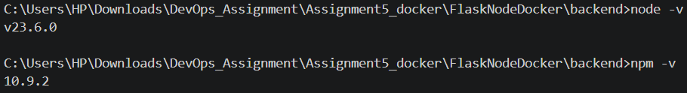
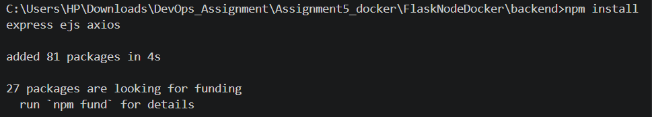
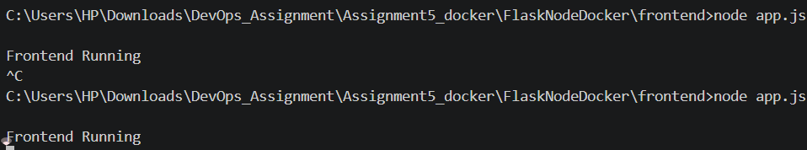

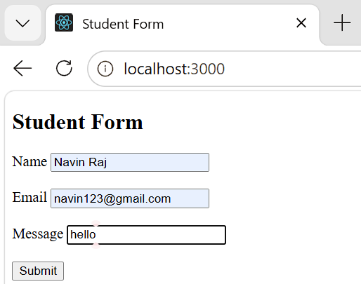
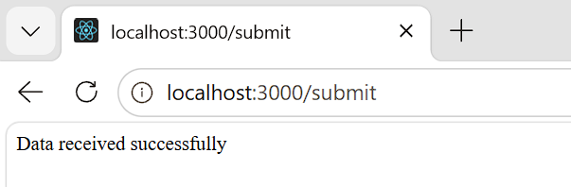

Git hub Repository Link:
https://github.com/sushilkumar121225/devops-assignments/tree/main/Assignment%205

